
Introduction to DOSBox
Lab 5

Computer Organization and Assembly Language

Student Name | Muhammad Hassan Khalid
Registration # | 21L-5692
Instructor | Hazoor Ahmad
Class | CS3
Section | A1, A2, D1, D2
Semester | Fall 2022

Fast School of Computing
FAST-NU, Lahore, Pakistan

Activity 1

Assembly Language Code
[org 0x0100]
jmp start

S1: dw -3,-1,2,5,6,8,9
S2: dw -2,2,6,7,9
intersection: dw 0
counter: dw 0
counter1: dw 0

addtoarray:
mov [counter1], si
mov si, [counter]
mov [intersection+si], ax
mov cx, [intersection+si]
add si ,2
mov [counter], si
mov si, [counter1]
jmp l1

intersection1:
mov si, 0
l6: mov di, 0
l2: mov ax, [S1+si]
mov bx, [S2+di]
cmp ax, bx
jz addtoarray

l1: add di,2
cmp di,10
jnz l2
add si,2
cmp si,15
jnz l6
ret

start:
call intersection1

mov si,0
l4: mov ax, [intersection+si]
add si, 2
cmp si,6
jnz l4

mov ax, 0x4c00
int 0x21

Debugging Screenshots

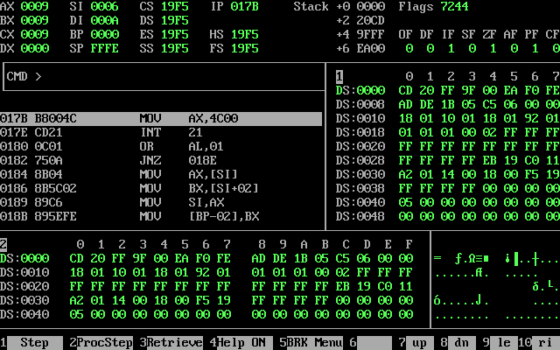

Activity 2

Assembly Language Code
[org 0x0100]
jmp start

findingones:
l1: shr ax, 1
jc l2
l3: add dx, 1
cmp dx, 16
jnz l1
mov dx, 0
add si, 1
cmp si, 1
jz l5
cmp si, 2
jz l6
cmp si, 3
jz l7
cmp si, 4
ret

l5: mov ax, bx
and ax, 0x0F00
jmp l1

l6: mov ax, bx
and ax, 0x00F0
jmp l1

l7: mov ax, bx
and ax, 0x000F
jmp l1

l2: add cx, 1
push ax
mov ax, 0x0000
shr ax, 1
pop ax
jmp l3

start:
mov ax, 0x5692
mov bx, ax
and ax, 0xF000
mov cx, 0
mov si,0
mov dx, 0
call findingones

mov ax, 0x4c00
int 0x21

Debugging Screenshots
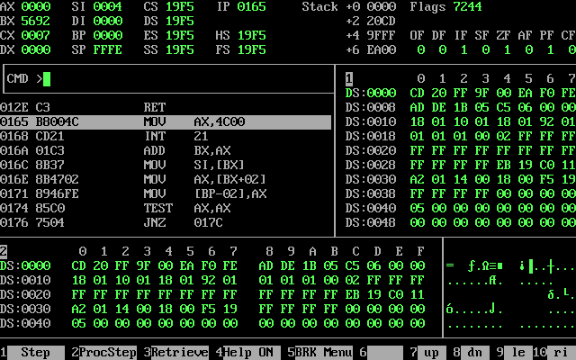

Activity 3

Assembly Language Code
[org 0x0100]
jmp start

findingones:
l1: shr ax, 1
jc l2
l3: add dx, 1
cmp dx, 16
jnz l1
mov dx, 0
add si, 1
cmp si, 1
jz l5
cmp si, 2
jz l6
cmp si, 3
jz l7
cmp si, 4
ret

l5: mov ax, bx
and ax, 0x0F00
jmp l1

l6: mov ax, bx
and ax, 0x00F0
jmp l1

l7: mov ax, bx
and ax, 0x000F
jmp l1

l2: add cx, 1
push ax
mov ax, 0x0000
shr ax, 1
pop ax
jmp l3

start:
mov ax, 0x5692
mov bx, ax
and ax, 0xF000
mov cx, 0
mov si,0
mov dx, 0
call findingones

mov dx,0
l11: mov ax, 0
add ax, cx
add ax, 5
mov bx, ax

l8: sub bx, 1
add ax, bx
add ax, bx
cmp bx, 0
jnz l8

add dx, ax
sub cx, 1
jnz l11
add dx, 0x3D

mov ax, 0x4c00
int 0x21

array:dw 0

Debugging Screenshots
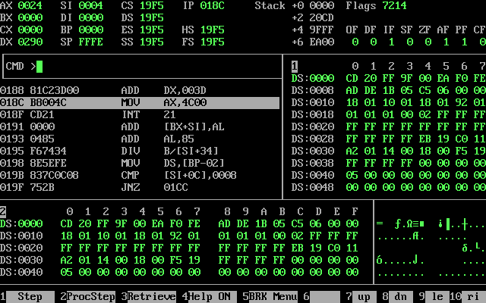

Activity 4

Assembly Language Code
[org 0x100]

jmp start

multiply:

mov word[a], ax
mov word[b], bx

mov cx, 16

l1:

shr word[b], 1

jnc skip1

mov dx, [a]
add word[result], dx

mov dx, [a+2]
adc word[result+2], dx

skip1:

shl word[a], 1
rcl word[a+2], 1

loop l1

add word[result], bx
adc word[result+2], ax

ret

start:

mov ax, 5237h

mov bx, ax
not bx

call multiply

mov ax, 0x4C00
int 0x21

a: dd a
b: dw b
result: dd 0

Debugging Screenshots
